**Version June 6th, 2013,** with comments / inputs included from (in sequence of receiving them)

* Leif Edvinsson
* José Maria Viedma
* Peter Pawlowsky / Aylin Gözalan
* Jean-Eric Aubert
* Susanne Durst
* Julia Stein (external)

**A New Generation Contract –**

**a proposal from The New Club of Paris**

Date of this version (indicating that this paper is and will remain “work in progress”): June 1st, 2013

Authors: **Günter Koch** (lead); contributing - names in order of alphabet: **Jean-Eric Aubert, Susanne Durst,** **Leif Edvinsson, Aylin Gözalan**, Hank Kune, **Peter Pawlowsky, José-Maria Viedma**

1. Summary
2. The „Generation Contracts“ as exist
3. Today’s distortions
4. Needs and requirements of the different „agers“
5. The market place
6. The “social generation exchange” currency
7. The potential projects suggested by the NCP
8. **Summary**

Europe is facing a new political, social and economic problem: the “inversion of the generation contract”: Many European countries face a high unemployment rate of young people and, at the same time, high standards in social rents for the elder generation, this leading to the effect that no more the younger “pay” for the elder rather than the other way round.

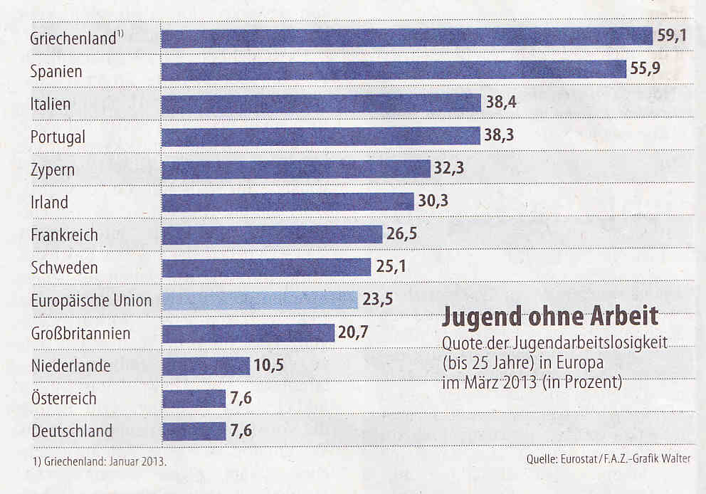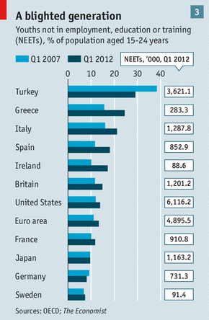

Fig. Youth unemployment up to age 25 in European

Situation in Q2 / 2012 – development since

countries in January 2013

The problem is complex because it goes beyond the simple one- dimensional discussion w.r.t. economic crisis beyond the national dimension, demography, in specific aging, youth unemployment, social security models, employment models being substituted, organization of work, new lifestyles etc. etc. Sample questions of our modern society of today would be: What is a young non-employed IT entrepreneur, who statistically is regarded as unemployed? Or: is a part-timer senior, acting in service jobs, unemployed if seen through statistics? Or is productive knowledge and competence ending when retiring at a certain legal “contract age”, say e.g. 65 (or 67 as today in Sweden or Germany) ?

The New Club of Paris addresses these questions, not claiming to be an expert in one of the disciplines related traditionally. It rather aims at proposing to prototype i.e. to try out new contract and occupation models. The goal is to contribute to avoid to allow human competences and work energy to stay in an idle or in a waiting state.

Models of new “organization of work” in the knowledge society are emerging. A demonstrative example may be how Google is moving from classical “Human Resource Management” towards “People Operations” by applying smart algorithms the purpose of which are to link up diverse but complementary competencies within their company resp. networks for the benefit of all those employed. In other organizations approaches are taken to discover the potentials of employees beyond what is documented in their job descriptions, e.g. by exploiting self characterizations which people voluntary give through their inputs to social networks.

Starting by some analytical discussion on the said multidimensional subjects of concern, **this memorandum introduces the concept of an “all generation social currency”** motivating for exchanges of beneficial services between younger and elder generations (potentially with the “bridging support” of the middle generation) in both directions.

This programmatic paper closes in **suggesting six projects for prototyping new approaches leading to new foundations for a future “cross generation society”**. These projects are templates and may be complemented by further innovative ones, all aiming at solving the current growing divergence between the generations in their social and societal demands and obligations.

1. **The „Generation & Labor Market Contracts“ as exist**

One of the grand achievements in social politics of the last 130 years in Europe was the introduction of social security. This went synchronous with (1) labor market developments introducing wage contracts as well as unions representing the interest of workers, instead of so far existing various forms of feudalistic patronage and (2) the concept of social security related to wages.

The core intention of social security was to provide each citizen with material and health security, in Europe based on a Christian value notion which demands for supporting the subsistence of your own family as well as of your next neighbors. In the industrial age, when social issues became a mass problem, governments took initiative to regulate this domain, e.g. in Germany “social laws” were introduced from on 1883 by O. v. Bismarck, a Chancellor who, by his feudal background, was certainly not to be expected to eagerly engage in such questions, but the dramatic social problems became too virulent at that period. The tradition in social regulation which Bismarck initiated in Germany was further developed in the post war period from on 1947, when the so called liberal school, based on what was called the “social ethics” promoted e.g. by the (Catholic) Church in the highly industrialized region of North-Rhine Westfalia, developed the concept of the “social market economy”. This concept attempts to combine liberal market regulation with social security conditions.

Without going into deep details, the **two major modes in financing social security**, i.e. paying for health maintenance, for social subsistence and pension are:

* *First*: Financial capital based [1], which, in principle, is an insurance model by which the beneficiaries are those who are no more able to earn their money by their own efforts, i.e. usually sick or aged people,
* *Second*: Generation or work life cycle based financial support of those who are no more able to support themselves by own endeavors to earn their subsistance , financed by those members of society who are working, as is regulated by wage contracts combined with social insurance and pension agreements.

This second concept, i.e. the generation contract, is based on the idea, that the younger generation by their potencies and work income provide the financial means for paying for those who need social welfare, especially for the elder ones living from their pension. As an intermediary, the state through its legal instances which have been created for collecting and redistributing social funds – in most cases also co-financed from taxes – guarantees the “fair” channeling of the money raised from the younger towards the elder generation.

So far theory. And this theory only works for countries of which their economy is strong and growing (e.g. the Nordic countries or the German speaking nations in Europe) or for wealthy countries due to other income effects (Norway, Switzerland, Luxemburg etc.). However, even for currently well doing countries like Germany, the International Monetary Fund (IMF) calculates a “hole” in financing pensions to the year 2050 of 2,000 Billion (2 Trillions!) Euros.[2]

In the majority of European countries, especially in the South, the generation pyramid formula starts to invert: No more do the younger pay for the elder, rather than the elder ones have to pay for the younger: At an unemployment rate of 50% of the young generation standing at the doorstep to enter their first employment in Southern Europe, this social disaster so far only could be stood because of the in-kind support of parents and grand-parents offering their children ongoing funding for their subsistence. **The old generation contract is broken and we need a new one comprising all generations.**

Fig. 1: Example Germany with a typical profile for Europe: the elder take the majority

1. **Today’s distortions**

At the time when The New Club of Paris was founded in 2006, one assumption was that the “economy of the immaterial” would open new job/value creating opportunities transforming us into a new society – the knowledge society - offering less capital in waiting by means of new types of jobs.

This change indeed generated new job and employment opportunities, but most of these are not stable, not eternal, not fitting to everyone, they are volatile and presume flexibility in all dimensions: location, time, qualification, energy… This new picture does no more fit with the traditional understanding which is reflected by the labor market authorities and institutions: The employment bureaus continue to administrate a kind of “employment” which, at large, does no more exist.

We have to face that we live in a world of radical changes in which we are challenged to find new ways in “pacifying” the so called lost generation, i.e. the young generation especially in many European countries. They are “sandwiched” between the following poles, without that they could perceive an escape:

|  |  |
| --- | --- |
| **Traditional** | **Now and in future** |
| Firm employment | Temporary employment, flexible affiliations, self-employment |
| One / little dimensional education; home language sufficient | Many different and multidimensional qualification, mastering several languages |
| Local employment | Non local, international(mainly expected in the next years), flexible |
| Manual and “practical intelligence” required | Intellectual capabilities needed; capability of quick adaption to new environments |
| Social security guaranteed by state | Self support in social securisation assumed |
| Stable, mostly hierarchical or central structures | Fading of classical structures, self organizing networks |
| Local fluctuation | Global fluctuation |
| Integrity of real and financial economy | Disintegration of real and financial economy |
| Mono references in economic figures (GDP, currencies, …) | Multiple references, dissolutions, multicurrencies |
| Governing paradigms are logic and follow a world interpretation based on natural science “axiomatics”, founded in occidential philosophy | New paradigms are based on new insights in the “nature of nature”, such as quantum physics, which provokes a new “structure of thinking / understanding” |



Fig. Paradigmatic changes in recruiting employees as an example of current change[3]

As already good old Albert Einstein said: You can’t solve problems by the means by which they have been created. Thus, our fantasy is challenged to identity new ways to overcome the dichotomies pointed out before.

The New Club of Paris does not own the philosopher’s stone, but it has the potential to create unconventional ideas and making suggestions in how to transform them into practice. This is the key purpose of this paper.

1. **Needs and requirements of the different „agers“** (in employment status)

Although this is an illegitimate simplification, we nevertheless need to take notice, that in different age phases, people have different needs which need to be covered in different individual ways. The following simple scheme may provide for a basis for further discussion and for setting up projects to be created or supported and promoted by the NCP:

|  |  |  |  |
| --- | --- | --- | --- |
| **Category** | **Young, entering working market** | **Middle age, in job, partly growing family** | **Elder, phasing out from classical labor market** |
| **Material / money** | Humble needs; subsistence must be possible | Material security needed, mostly I order to support own family. In traditional minds: Generation of income for future security | Social and medical security must be guaranteed. Saved money partly can be invested in next generations. |
| **Main concerns** | Finding role in society. Finding senseful job. Getting along with friends /same agers | Safeguarding what has been achieved so far. Making career. Too little time to spend the money which is earned | Designing last stage of life. Maintaining health. Finding a role to the good of society. |
| **Perspectives** | In the old categories limited options – if not zero. New options not well defined / hard to acquire. Need a vision for acquiring hope. | Seemingly stable, but there is no guarantee for the future, in specific not when it comes to social security Have to carry most of the burdens of social cost. | Currently good outlook. In the longer run due to devaluations stress in maintaining living conditions. Supporting children / grand children |
| **Means for information and communication** | Internet based, permanent and ad hoc communication, fast adaption | Modern means of telecommunication is natural part of permanent professional and private communication | Personal communication preferred, use of classical media (TV, newspaper, …) |

In a larger picture, the question will be how the generations are in a position to help each other with their potential and material as well as immaterial means.

By a banal and therefore valid conclusion we must assume, that the different age groups have different interest in “social goods” (available for exchange) which, due to limitations in time, space, money and availability may not be allocated in optimal ways, i.e. the analysis of the malfunctioning of “social markets” may provide us with ideas how we may contribute for solutions.

The question becomes even more complex and a perspective in finding new societal models becoms urgent if we consider the “new employment structures” which have been predicted since long: Large employers more and more outsource their work. E.g. in german car industry, between ~70 % (e.g. BMW) and ~ 90% (e.g. Porsche) of production contribution has been shifted to third parties.

Mainly in the service field, we must face a structure which is predicted as follows:

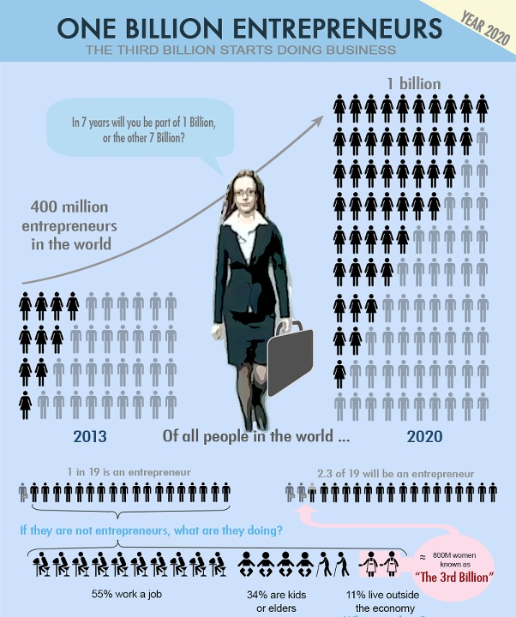

1. **The new market place: Exchange of knowledge & competence**

In our discussion we come to the conclusion, that **we need “a new generation contract”, which is based on the following principles:**

* It covers **all generations**
* **Data needed** for understanding the situation and the dynamics shall be acquired from competent organizations such as OECD and the World Economic Forum (WEF), which is already in progress resulting in a deeper understanding of the value adding dimensions, i.e. new accounting statistics, as well as the National Intellectual Capital (NIC) mappings.
* Implementation of the **“new generation contract”** will be accompanied by exploiting the intellectual capacities of **universities, think tanks, intellectual circles, NGOs** etc. them creating ideas for overcoming deadlocks in social innovations for services interchanges between generations.
* **NCP’s Multiversity** and online/virtual Learning Platforms across Generations and Cultures, primarily devoted to the silver generation, shall play a key role.
* **Currency** is not (only) money, rather than **“services in exchange”**. E.g. elder generation can teach, babysit, care for households, mediating contacts e.g. in their old boys’ / girls’ networks etc., younger can engage in purchasing, gardening, repair, telemonitoring… This approach is already prototyped in a series of places in USA, Greece, and other countries as a **new Social Capital Currency**.
* Based on self organized platforms and processes, such as – in technical terms - Google+ or- in social terms - **learning after “The Hole in the Wall” paradigm** or the Aalto Campus for Societal Innovation (ACSI) and similar.
* Model and prototyping projects creating references for **new “social generation products”** shall be continuously identified, collected and evaluated for acceptance / recommendations
* **Main and ultimate beneficiaries shall be the young generation**: e.g. new jobs can be created in care for elder people or by projects following the dual education model or, or or..
* …

1. **The “social generation exchange” currency**

Assuming that we look for the solution of the generation problem by promoting or fostering Social Network markets for exchanging social services, we assume that we will need a currency beyond money for exchanging such goods.

This idea is not new and has been experimented already in Japan or the UK in terms of time offered by elder or younger people. One such project and study has already performed in 2007 and has been reported[4]

We suggest first to identify some six prototyping projects demonstrating how elder people can engage for job/value creating activities for the younger generation and, vice versa, how the younger generation in return may support the elder one (including middle agers as “bridge builders”). This today is often referred to as **Societal Entrepreneurship** shaping New Social Capital. This has been researched, among others, by Robert Putnam, and nowadays also by emerging schools of “Social Entrepreneurship”, like at Sweden’s Malmö University, as well as intergovernmental set-ups such as NESTA in UK, an organization supporting the implementation and instantiation of new ideas.

This paper also shall lay the grounds for taking NCP’s inspiring initiatives and Society Innovation Alliances to identify further options, how the “new generation contract” shall be designed. Once diverse models have been collected and exercised, we will systematically categorize and we will turn our insights in concrete (business resp. organizational) models.

We consider the possibility to be invited to participate in European Commissions’s Innovation events as opportunities to present our ideas thereby infusing them into the ongoing public communication.

On European level **we may consider a “Multi Generation ERASMUS program”** which may not only enable students to go for visiting universities abroad, there acquiring credit points (which, by the way, also forms a special “currency” like the suggested “social generation exchange currency”) rather than also to build social contacts beyond the world of universities in international level. Indeed: why not extending the educational / intellectual credit point system by adding “credits” in social services rent at Erasmus study locations?

1. **A resumee: The potential six projects suggested by the NCP**
   1. **Re-Energizing Europe (RES)**

In 2012, facing the dramatic economic and social changes in Europe and tendencies of failure of the European idea, the NCP set forward the idea to create a students’ movement going beyond Erasmus-type exchange. The “Re-Energizing Europe” (RES) project aims to explore, capture and fuel the energies and motivations of different generations across Europe in telling their own story and images on a future Europe. People will get cognitively involved into socio-political deliberations and actions when they are emotionally driven and touched by the issues at hand. If Europe’s Intellectual Capital is the source for sustainable value creation, genius is that *energy* which collects, combines, amplifies, and animates this international intelligence.

Against this background the project’s intention is to let people all around Europe speak up about their aspirations and ‘hot socio-political challenges’ which they feel strong about in order to foster the idea of a common Europe. In playful and creative ways student groups in different places in Europe can help to access the voices of people across Europe (by means of videos, short articles, pictures etc.). Spreading the stories through social media such as *youtube* shall help to inspire others across Europe to add their own stories in support and to deploy their energies so that a more inclusive coverage of different future perspectives can be given.

For raising contributions, the following initial themes may help to display the contributions:

*Identification with Europe and / or images about a future Europe:*

E.g. How strong do the people in their communities identify with Europe? In what kind of Europe do they want to live and participate in? How can level of constructive participation be increased (besides the solidarity demonstrations on the streets?)   
  
*Societal problems people feel strong about and / or care about:*

What would the different generations like to change/make better in their neighborhood, at their university/workplace, in their town, in their country, in the world? What are the most urgent challenges they feel strong about and would like to tackle?  
  
*Competence acquisition and education as a promise for future success?!*

What are the most important values/goals in the lives of younger generations? Do they think that competence/education is a ticket to reach their professional/personal goals - Is education/competence regarded as a means for a happy future/their personal well-being?

* 1. **Creating an Institute for Advanced Studies concentrating on age of humans, and, even more important, on aging issues**

In a first instance The New Club of Paris developed the ideas to create a true Seniors’ University with the draft name of “Humboldt Cosmos Multiversity” since it was invented in occasion a meeting of The New Club of Paris on Tenerife.This “university”, in a first instance was thought of to be devoted for elder people and a true international, multifaceted and multilingual institution.

In concept it shall follow new and even futuristic paradigms and concepts both in working modes, methodologies and in its structure. The differences between such new and conventional (seniors’) universities are identified to be, that…

… it will be designed w.r.t. the special potential of elder people, who have life experience and wisdom. I will have its own philosophical principles based on future-minded insights and paradigms,

… its topics and themes are devoted both to the needs of elder people, but also the results of the research work produced at the HKU are of long reaching importance and of benefit both for society and economy in the future.

The “research branch” of this university shall be developed as an “Institute for Advanced Studies” (IAS) following the original model of the famous Princeton IAS. Its main mission shall be to provide for studies on highest level of excellence on subjects of aging, age issues in lifecycle and social balancing out differences in age in society. It also shall be a place for retired scientists and thinkers who, naturally being liberated from their professional duties, finally can do independent and unconventional research and communicate on it to a larger public.

* 1. **Patronage of the younger**

One general paradigm in education is that complementary to the knowledge acquisition, young generation are formed and developed by former generations. In most cultures, the teacher – scholar relationship has been a fundamental model for caring that the next generation not only masters their lives rather than also improves beyond.

As an institutionalized version the master – apprentice model combined with a school – workshop model as having been exercised since generations in the German speaking countries shall serve as a reference in this dimension. It became public, that in the current crisis some Southern European countries such as Spain adopted these dual models, even in higher education (e.g. the model of a “University of Cooperative Education”)

The responsibility of the elder generation is not only to enable the younger generation to make their way in order to support their lives, but also is to engage to increase the opportunities for successful societal and material careers of the young generation.

Since the public and political measures can not solely supply for such support, members of the elder generation shall be motivated at large to support younger generation people to enter the working or entrepreneurial market.

The objectives of the projects in this domain shall be to…

… stimulate existing movements in “seniors help younger” mainly established in many countries for supporting young entrepreneurs, to cooperate with each other on a European scale,

… to inform and to motivate qualified and socially well connected members of the elder generation to engage in taking patronship/s for young persons such as graduates from universities to work out together some concrete measures in order to get them introduced in situations where they may find a job easier than if they would try on their own.

… to educate elder people in professional coaching of younger

...to establish a matchmaking service on European level by which patrons can find cases and vice versa.

* 1. **Extending the Caritas movement**

Since the inauguration of the new Catholic Pope Francesco in 2013, for good reasons the attention has been raised again on organizations like Caritas (or, in the protestant community e.g. in Germany: Diakonie) and their social work, because of the evident growing need for qualified social services. (By the way, it is widely unknown, that the largest non-public employer in Germany is Caritas with more than 500.000 employees. Caritas “in substitution” for the public obligation in social service, takes responsibility for keeping social life in a good and peaceful balance).

Although salaries / payments for Caritas work may not compete in comparison with what is paid in industry, employees in Caritas report that they are most satisfied with their jobs, since they have to work close and also emotionally close with people needing help, mostly in caring for those who need special attention and care, which prominently includes the oldest, the handicapped and those with physical or mental disease.

Designing social services such as offered and organized by Caritas, to become more and more attractive for young people e.g. by campaigning for engagements in social, but also intellectual services for elder people and thus creating working and income opportunities would be the key subject of this project.

* 1. **Create the social currency in reality**

Exchange of social services and organizations providing for such services (“baby sitting by elder persons versus shopping for them by the younger”) is not a new idea, but limited to a local or regional dimension. For “intangible” social services across borders, the internet provides new options such as e.g. “private teaching by an elder versus instruction on how to use sophisticated technology like a smart phone by a younger” (E.g. see Kahn schools / university or “Hole in the Wall” movement).

The exchange of (especially intangible) “products” which have no market or in which case “the market” does not constitute a price would make it necessary to create new currencies more sophisticated and complex than can be represented by money.

The idea of this project is a) to identify “social products / services for exchange” and b) a currency suitable for valuing such “products / services”.

For defining this approach to become more concrete, we suggest to look in detail into relevant experiences among the thousands existing projcts in using "complementary currencies" being operated in the world in many different places, notably those currency projects which have a social and, at the same time, local dimension. After such analysis with the help of key experts in those new forms of currencies, a few experiments will be developed and tightly monitored. These experiments would preferably take place in different European countries with contrasting economic conditions and socio-cultural backgrounds.Based on the observations drawn from these experiments (to last one year at maximum), opportunities for extension and generalization will be discussed.

**6.6 Start of a prototype project in the field of statistical and quantitative monitoring of job and activity creation (Dynamics in work generation)**

The proposal of such project is to monitor job creation activities both in classical as well as in new employment and self employment scenarios as today’s main challenge by finding the fuction(s) employing basically three parameters: (1)competences, (2) ages of economic agents and (3) socio-economic conditions. The objective is to identify what the demand and supply of work / work supply from this triple perspective is, perceiving a better identification what the current and future potential trends will be[5].

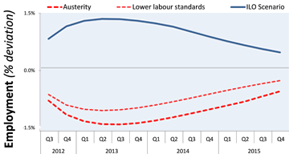

Fig. Forecast of employment in Europe due to the International Institute for Labour Studies (ILO, Geneva, 2013)

To do it in an efficient and innovative manner, also leading to early and fast results, the proposal is to use geo-localisation tools applied to a sample of well defined territories (localities) with the concourse of academic units in these regions. The approach would involve selected samples of economic agents to monitor their activities over a limited period by means self reporting mechanisms by using social media, thereby facilitating geolocalisation in real time. The pilots should be developed only in a few representative territories, preferably located in several European countries, with contrasting challenges and opportunities. This would be an innovative project in line with NCP’s mission and would create a model for profiling future statistical monitoring systems adapted to new technological possibilities and societal needs. A combination with the model of National Intellectual Capital (NIC) approach may be considered, however, this project as suggested will have its special quality in fast speed observation of changes.

1. One of the projects in which a large change in the system of social securisation towards a capital based approach was undertaken in the 80ies in Chile, when José Piñera, then Secretary of State, introduced a social savings book for everybody. (Piñera gave a private lecture on “his” project on capitalistic social security to G. Koch on occasion of the 1996 “Forum Mercosur” in Uruguay, when Europe and Latin America debated on their ways of cross border integration).
2. Due to an article”Barrierefrei” in the magazine ”DER SPIEGEL” No. 23, 2013, page 64.
3. Tim Weitzel et al @ Center of Human Resources Information Systems (CHRIS): Recruiting Trends Frankfurt / Bamberg, 2012
4. ### See Journal of Aging & Social Policy [Volume 20](http://www.tandfonline.com/loi/wasp20?open=20#vol_20), [Issue 4](http://www.tandfonline.com/toc/wasp20/20/4), 2008: (Quote): *“…Community currency systems attempt to empower the economically marginalized and build social capital. The elderly are potentially very important contributors, yet we know little about their participation in the local exchange networks. 87 months' worth of transaction data from a “time bank”…, was examined in social network analyses. Measures of quantitative engagement in the system were constructed. The elderly were found to be as active as other members. …Male and female seniors undertransact with themselves and with one another, generating bridging social capital. …The evidence presented suggests that the participation of the elderly in local currencies is usually beneficial …”*

  
5. It goes without saying that for such purpose data from the OECD and ILO (in Geneva) or studies form private Institutes such as from the Bertelsmann Foundation or, in Germany, the study on ”*Future Jobs - Wie wir in Zukunft in Europa arbeiten werden*“, a qualitative trend study in cooperation with the “Zukunftsinstitut” GmbH, Robert-Koch-Str. 116 E, D-65779 Kelkheim, Germany, will be exploited. However, we are convinced, that we also need to foresight and foresearch new employment models byond today’s understanding of work organization.